YES, I want to make a tax-deductible contribution to the LMMS Foundation.* LMMSF funds projects and programs that expand educational opportunities, foster creativity, and enhance the academic experience for LMMS students. Your contribution will have a lasting impact on LMMS and its students!
Please return this completed form and donation to the LMMS Foundation box or LMMS front office. You may also mail your payment to Lost Mountain Middle School, 700 Old Mountain Road, Kennesaw, GA 30152
*LMMS FOUNDATION, INC. is an IRS 501 (c) (3) non-profit corporation and your donations are, therefore, tax deductible. TAX ID # 47-2481503

LOST MOUNTAIN MIDDLE SCHOOL FOUNDATION GIVING

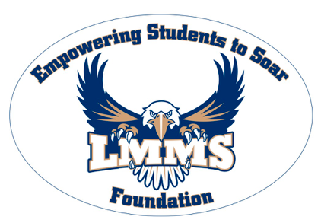
Name________________________________________ Email Address: ________________________________________
Phone: _____________________ Address: ______________________________________________________________
Student/Grade/Homeroom Teacher: _____________________________________________________________________
EAGLE FEATHER SPONSOR $250 Engraved feather featured on the Eagle Legacy Wall. Includes recognition on our LMMS website Honor Roll.

Please NEATLY PRINT your Eagle Feather inscription here. Maximum 2 lines, 15 characters per line (spaces included): __________________________________________________________________________________________
______________________________________________________________________________________________
GOLD SPONSOR PLATE $150 Engraved 2x3 plate featured on our Gold Sponsor Board. Includes recognition on our LMMSF website Honor Roll.

Please NEATLY PRINT your Gold Sponsor Plate inscription here. Maximum 2 lines, 12 characters per line (spaces included): ______________________________________________________________________________________________________
_______________________________________________________________________________________________________

SILVER SPONSOR $100 Recognition on our LMMSF website Honor Roll

BRONZE SPONSOR $50 Recognition on our LMMSF website Honor Roll

FRIEND OF THE NEST Any contribution will have a lasting impact on ALL Lost Mountain Students
Payment Options
1). My full donation is enclosed: Cash (amount) $___________ Check # (payable to LMMS Foundation) _______________
2). Credit Card: I will pay by credit card in the amount of $ _______________
Card Type: Visa Discover Card Amex Card MasterCard
Number: ________________________________________________________ Exp. Date______________________
Card Holder Name: _______________________________________________Security Code:___________________ Card Holder Signature: ___________________________________________________________________________

